NDSU Technology Learning & Media Center

**QBB 150C**  **231-5130**  [**www.ndsu.edu/its/tlmc**](http://www.ndsu.edu/its/tlmc)

**Creating a Large Format Poster (Plot) Using PowerPoint 2013**

Posters should be designed and created in a manner that best communicates your message in a visual, graphical manner, so the viewer can quickly discern your message and determine whether she/he needs to read more or move on to the next poster.

PowerPoint is one of the programs of choice for creating posters because Power Point is a user-friendly program and is readily compatible with other Microsoft programs such as Word and Excel. Other software packages that can be used for posters include (but are not limited to) Adobe Photoshop, Illustrator, InDesign, and FreeHand; Corel Presentations; and Microsoft Publisher.

This handout provides guidelines for using PowerPoint to create a large format poster.

Poster Size and Setup Grids, Guides, Ruler Using Shapes as Guides

Titles, Font Sizes, Body Text Background

Working with Pictures Working with Graphs Saving Slides as Pictures Printing the Poster

# Poster Size and Setup

First, create a single large slide in PowerPoint. When creating a poster in PowerPoint, it is a good idea to use a planning sheet to design your poster before creating it in PowerPoint.

Also, you will want to set your page (slide) size before you begin creating the poster. If not, your poster may not be printable at the size you need.

***TIP:*** It is a good idea to verify poster size requirements for the event at which your poster will be displayed. Often there are guidelines about poster size.

***NOTE:*** The maximum custom slide size that PowerPoint allows is 56 x 56 inches; however, the ITS plotters are 36 and 42 inches wide, so either the width or height setting must accommodate those limitations. If you need a larger size (e.g., 36 X 60), set up your poster for half the size, so it can be enlarged proportionately later. (Remember, some graphics will lose quality when enlarged.)

**Margins:** The plotters will not print to the edges of the paper because of a quarter to a half-inch default printer edge; therefore, set one of the measurements at a half-inch (35.5 or 41.5) or an inch (35 or 41) less than the total width of the paper. An inch of white space around all the edges is visually appealing.

1. 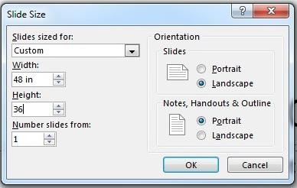In PowerPoint, click the **Design** tab, and in the

**Customize** group, click **Slide Size** > **Custom Slide Size…**

1. In the **Slide Size dialogue box** (shown on right), under

**Slides sized for:,** select **Custom.**

1. Specify **Width** and **Height** of poster.
2. Under **Orientation**, specify **Portrait** or **Landscape**.
3. Choose **OK**. A dialogue box will appear, asking you whether you want to maximize the size of your content. Click the **Maximize** button.
4. Click on the **Home** tab, and in the **Slides** group, click on the drop-down arrow next to **Layout**. Select a **Blank** layout.

Once this is done, you are set to start working on your poster. This is where any planning documents will be helpful.

# Grids, Guides, Ruler

Use the ruler, gridlines, and guides to position shapes and objects more precisely.

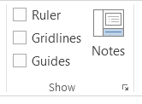

1. On the **View** tab, in the **Show** group, toggle on and off **Ruler, Gridlines, Guides**.
2. For more options, click the dialogue box launcher (circled in image on left).
3. 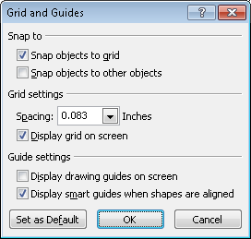In the **Grid and Guides** dialogue box, you can enable the **Snap objects to grid** option, set spacing measurements for the grid, under **Grid settings**, and display or hide drawing guides, under **Guide settings**.

***TIP:*** To temporarily override the “Snap to” feature while you are working, hold down the **ALT** key on your keyboard while you drag the shape or object.

# Using Shapes as Guides

Consider using shapes to define the areas of the title and to set the flow of

text and objects in your poster. You can delete the shapes later if you only want to use them as placeholders.

1. To draw shapes, click on the **Insert** tab, and in the **Illustrations** group, click on the **Shapes** button.

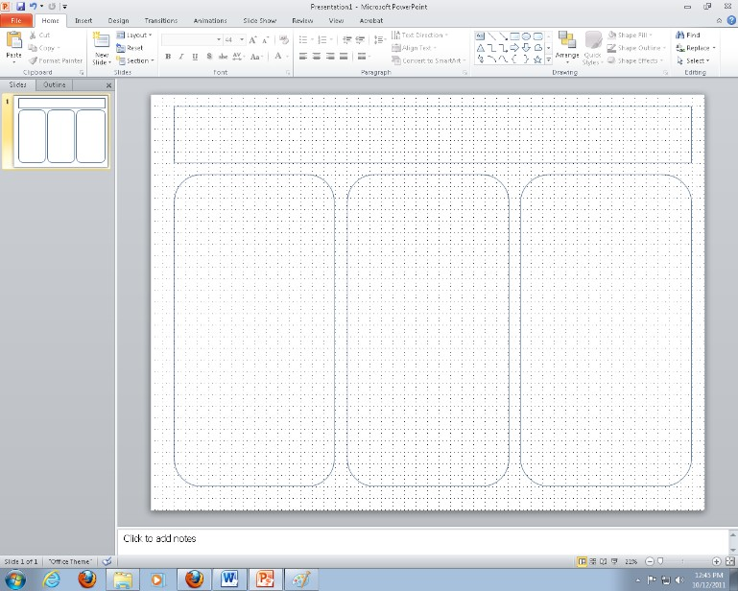

1. Select a shape and draw the object on the slide by holding your left mouse button down and dragging.
2. To access **Drawing Tools**, click on the object (Shape) you have inserted and the **Drawing Tools** tab should appear above the **Format** tab. (The **Drawing Ribbon** is shown below.)
3. In the **Shape Styles** group, click **Shape Fill**

and select **No Fill**.

1. Copy and paste your shape as many times as necessary for your layout.

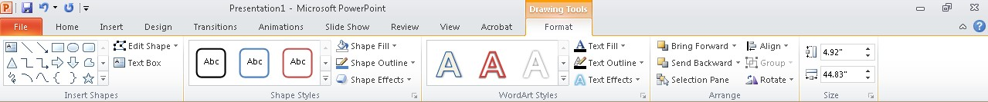

1. **Align your Shapes**: Select the shape(s) (hold the **Shift** key down while selecting multiple objects), and from the **Drawing Tools** ribbon, in the **Drawing** group, click **Arrange** and view options to align and distribute objects evenly (e.g., **Align Top** and **Distribute Horizontally**). Using these **Align** tools will help you create a more professional-looking poster.

***NOTE*:** PowerPoint 2013 has handy, built-in alignment guides that appear as you move and place shapes or objects.)

1. When you are finished creating your poster, you can delete the shapes if you wish. Or if you keep them, you can modify them by changing the border color and weight, changing the shape fill and effects, etc., using the options on the **Drawing Tools** ribbon.

***TIP:*** Leave at least one inch of space between each column, more if the poster is very large. Also, leave an inch around all sides of the poster, if you can—a wider margin looks better than getting too close to the edge.

# Titles, Font Sizes, Body Text

The title is the first thing your reader will look at. Your title should be interesting, easy to read and understand, and encourage the reader to check out your poster in more detail. In addition, the formatting of the title can set the mood for the entire poster. For the title, consider using a large, bold san-serif font, such as *Arial Black, Franklin Gothic Medium, Tahoma, Trebuchet***.** Make the font size between **72-120 points**. (72 points = 1 inch)

* For the **subtitles** (authors' names, school name, etc.), use the same font as your title but make the font size smaller than the title. A font size between **48-80 points** usually works best.
* For the **section headers** (Abstract, Introduction, Results, etc.), use the same font as your title and subtitle. Make the font size approximately 50% larger than the body text, between **36-72**

**points**. Make sure that all section headers are the same font size.

* **DO NOT USE ALL CAPS** in any part of your poster. Using all caps makes your text harder to read and it looks like you are shouting.
* For the **body text**, choose a serif type that is very readable, like *Garamond*, *Book Antigua* or *Bookman Old Style*. Make the font size between **24-48 points**. Make sure the body text is the same font throughout the entire poster.
* For paragraphs or blocks of text, **use left justify**. While full justify (justifying the text on both the left and the right) produces very neat-looking columns, a ragged edge is easier to read (really).

Working with Text

To include text in your slide, you need to insert a **Text Box** and type text into the text box. This will be a floating text box; you can move it anywhere you wish. (Remember, you can place text directly in your Shapes—simply right-click on the border of the shape and select **Edit Text**. But if you delete the Shapes, your text will also be deleted.)

* + To insert a text box, click the **Insert** tab, and in the Text group, click on **Text Box**.
  + Move your cursor to the desired location on the slide, and click and drag to create a text box. Note that the text box automatically resizes itself as you enter more text.
  + To change the font type, font size, font styles, font colors, etc., click the **Home** tab, and you will find options to change these properties in the **Font** group. You will need to highlight the text to apply these changes.
  + You can apply various effects and modifications to the text box and to the text by using the **Drawing Tools**. Click on a text box and the **Drawing Tools** tab will appear. Click on the **Format** tab (under the Drawing Tools contextual tab—shown below) and experiment with **Shape Styles** and other features of the **Drawing Tools** ribbon.

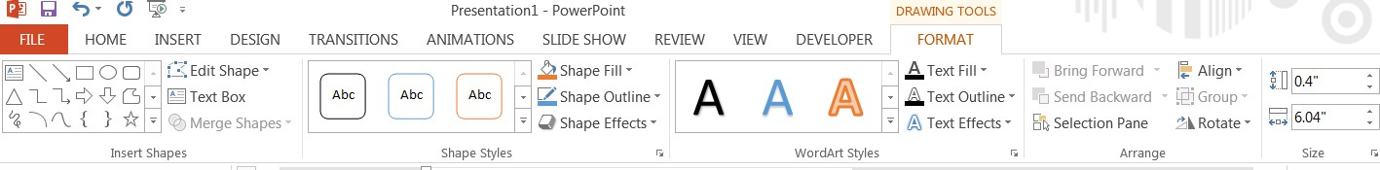

Right-click on the text box and select **Format Shape** (at the bottom of the list) to activate the **Format Shape** pane, where you can add a background and background effects to the text box.

# Background

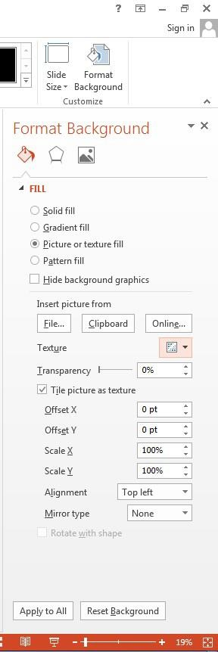

Fill – Effects - Picture

PowerPoint gives you many background options. You may choose to use a color, a color gradient, a texture, or even a picture as the background for your poster.

1. Click on the **Design** tab, then in the **Customize** group, click **Format Background** to activate the **Format Background** pane (shown on right).
2. Try out various options for **Solid fill** and **Gradient fill** (note color, transparency, and special gradient options).
3. To apply a picture as a background, under the **Fill** category, click

## Picture or texture fill.

1. In the **Format Background** pane, under **Insert picture from**, click the **File**, **Clipboard**, or **Online…** button and select an image.
2. Change the transparency of the picture by using the

**Transparency** slider.

1. Click on the **Picture** button at the top of the **Format Background** dialogue box to access options for modifying the picture (**Picture Corrections, Picture Color)**.
2. You can apply various color and artistic effects by opening the **Effects** options. Click the **Effects** button in the **Format Background** dialog box.

***TIPS:***

* Use **high contrast colors** between foreground and background. A light background with a dark foreground is the most readable combination.
* Allow enough **“white space”** to keep your poster from looking overloaded.
* Remember, combinations of red and green appear as grey to people who are color blind. Save this combination for Christmas only.
* Use the special effects in PowerPoint (for background and text) sparingly. Some PowerPoint effects do not print correctly (see next section).

# Working with Pictures

* To insert a picture, click the **Insert** tab, and in the **Images** group, click on the **Pictures** or **Online Pictures** button, and select an image from your computer or a clip art image online.
* To resize the image, click on the image and use the **corner handles** to resize; using the corner handles will maintain the perspective of the picture.

Clip Art—Vector Graphics

* + Consider using clip art (**Online Pictures** option). Some of the clip art in PowerPoint (and other MS Office programs) is line art (not pixels) or “***vector graphic files***,” so you can enlarge the images to any size with no loss of quality.
  + Vector format types include: WMF, EMF, and EPS
  + 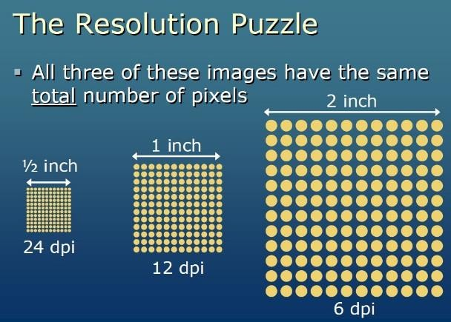You can **Ungroup** these clip art images into individual elements for editing.

Digital Images / Photographs—Raster Graphics

* + **Raster graphics** are composed of a grid of a finite number of dots known as pixels (not line art).
  + GIF, PNG, and JPG (or JPEG) formats are common raster files.
  + 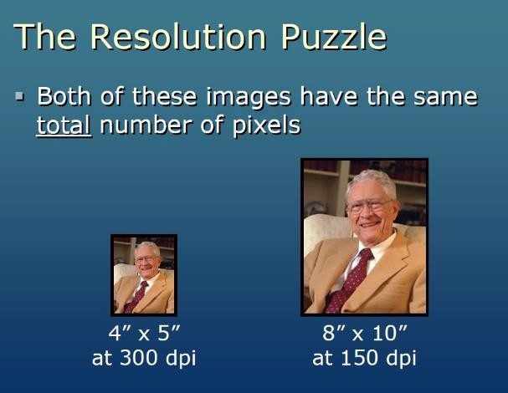A low resolution digital image file (a raster file) is one that does not have many pixels. You cannot add more pixels to an image file; when you enlarge a low resolution image file, the pixels are simply spread over a larger space, and the image loses quality.
  + A high resolution raster graphic (image) can sometimes be enlarged and still look good.
  + If you are planning to use a picture in a large format poster, always take the picture on a high quality setting on your camera and scan any pictures at a high resolution setting (at least 300 ppi).
  + You cannot Ungroup digital images into individual elements for editing, like you can with vector images.

***TIPS:***

* In your online search (**Insert** tab > **Images** group > **Online Pictures**), you can request results that include only images that are in .jpg format (raster) or only images that are .wmf (vector). Type the name of the item you are searching for and type the format after it. Examples: **flower .jpg** or **flower .wmf**
* Check the size of the images you use. Usually, the dimensions specified are in pixels.

**72 pixels = 1 inch**

* Pictures you find on the Web are almost always low resolution, unless specifically identified as high resolution. These images are for onscreen or Web page use only.

Using NDSU Branding Resources

NDSU logos are available for download on the NDSU University Relations Web site: <http://www.ndsu.edu/vpur/resources/> Read the Usage Guidelines and use the logos appropriately. ***Do not use an NDSU logo or picture from the NDSU Web site.***

Grouping

Grouping shapes, pictures, or other objects lets you flip, rotate, move, resize, or change the attributes of multiple shapes or objects at the same time as though they were a single shape or object.

* 1. To group two or more objects, select the shapes or other objects. (Hold the **Shift** key down while selecting multiple objects.)
  2. Under **Picture Tools or Drawing Tools** (depending on what type of objects you have selected), on the **Format** tab, in the **Arrange** group, click **Group**, and then click **Group**. **OR** you can right- click on one of the selected objects and click **Group** > **Group**.
  3. To Ungroup, follow one of the procedures above, and click **Ungroup**. Change Order

PowerPoint allows you to work with layers—to bring objects, placeholders, or shapes to the front or send them to the back.

* + Right-click the shape and select a menu option to move it to the front or back (**Bring to front** or

**Send to Back**).

# Working with Graphs

For best results, create your graphs in Excel and then copy and paste them onto your poster slide.

1. In Excel, create your graph. Right-click on the graph (the outside border to select all of it) and choose

## Copy.

1. Return to PowerPoint and choose **Edit > Paste**. (The shortcut keys CTRL-C and CTRL-V work, too.)
2. If you need to resize your graph in PowerPoint, select the graph and drag one of the **corner handles** (not the ones on the sides, top or bottom). Hold the **Shift** key down while resizing, to retain proportion.
3. You will probably need to enlarge text elements of your graph. To do so, right click on each text element and enlarge the font size (24 is a readable size) in the dialogue box that appears.

***TIP:*** If you change the relative height and width of your graph while resizing in PowerPoint, all text in the graph will be distorted. However, this will not happen in Excel. If you want to change the proportions of your graph, do it in Excel before inserting it in PowerPoint.

# Save Slide(s) as Picture(s)

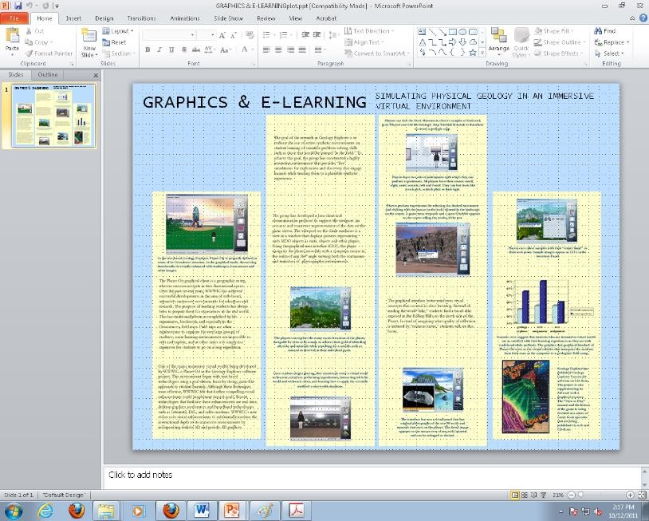You can export one or more slides and use them as pictures in your poster.

The figure on the right is an example of a poster created from an existing slide show.

* Each slide will be a separate graphic.
* Put only one or two elements on each slide.
* Use consistent background colors and text sizes when creating your PowerPoint slide show.

Save Slides as TIFF Images

First, export all the slides in your slide show as TIFFs (an image format that retains quality). You can also create just one slide and save it as an image file in this way.

* 1. Open the existing PowerPoint file.
  2. From the **File** tab, select **Save as.** Click on **Computer** and select the **Browse** icon and browse to where you want to save your image(s).
  3. Click on the drop down menu next to **Save as type:** and select **TIFF Tag Image File Format (*.tif)**.
  4. Click the **Save** button.
  5. Click **All Slides** or **Just This One** at prompt.
  6. TIFF images will be numerically saved in a folder named after the PowerPoint.
  7. Close file.

Create a Poster from Exported Slides

1. Create a new PowerPoint file: Click on the **File** tab, select **New**, and double-click on the **Blank Presentation** icon.
2. Specify the size of your poster. (See section on **Poster Size** in this document.)
3. Insert TIFFs: Click on the **Insert** tab, and in the **Images** group, click **Picture**.
4. Navigate to the folder containing the TIFF files, and select all the slides (**CTRL-A**).
5. Click the **Insert** button. Click and drag pictures to resize, place, and position them.
6. Add title, change background, etc. Save as a PowerPoint file when finished.

# Printing the Poster

Setting Print Options

Some special features in PowerPoint, like transparency and shadows, may not print correctly. Setting some print options may help.

1. Click on the **File** tab and then click on **Options**.
2. In the **PowerPoint Options** dialogue box, click on **Advanced**.
3. Under **Print** (you will need to scroll down the page), enable the **High quality** option.
4. To ensure best quality for your images, under **Image Size and Quality**, check the box next to **Do not compress images in file** and be sure the **target output** for printing is set to **220 ppi**, the highest possible setting.

***TIP:*** Always use high quality images, especially when you need to enlarge them. See the section on

**Working with Pictures** (page 5) for information about resolution and image formats.

Sending the Poster to the Plotter

Take your file to the Technology Learning & Media Center (TLMC) in QBB (formerly IACC) 150C and have a TLMC staff person help you set up the poster for printing and send the poster to the plotter. If a TLMC employee helps you and your poster does not print correctly, you will not be charged for printing it again.

You will take the plotting slip filled out by the TLMC employee to the Help Desk window in IACC 150 and pay for the plot. You must use Bison Bucks to pay for the plot. Later, you will pick up your plot at the same window.

You can find more information about plotting (e.g., cost, paper types) and about the TLMC (e.g., lab hours) at the TLMC Web site: [www.ndsu.edu/its/tlmc](http://www.ndsu.edu/its/tlmc)

***TIP***: You can print the poster on letter-size paper to preview it. In the **Print** dialogue box, find the **Scale to fit paper** option, and then click **OK**.

See **Learning Links** on the TLMC Web site for links to many tutorials on using PowerPoint.

***For more information, contact:*** [***ndsu.tlmc.support@ndsu.edu***](mailto:ndsu.tlmc.support@ndsu.edu)